Lecture 3 Symmetric Encryption

# Cryptography

Cryptography is the study and practice of techniques for secure communication in the presence of third parties called adversaries. It deals with developing and analyzing protocols that prevents malicious third parties from retrieving information being shared between two entities, thereby following the various aspects of information security. Secure Communication refers to the scenario where the message or data shared between two parties can’t be accessed by an adversary. In Cryptography, an Adversary is a malicious entity, which aims to retrieve precious information or data thereby undermining the principles of information security.

Through cryptography, data and personal information undergo transformations to ensure that only the intended recipient can decipher the message. By employing cryptography, which is a vital component of contemporary data security, data can be stored and transmitted securely between parties who willingly participate in the process.

Data Confidentiality, Data Integrity, Authentication and Non-repudiation are core principles of modern-day cryptography.

# Core Principles of Cryptography

## Data Confidentiality

Data confidentiality refers to the principle and practice of ensuring that sensitive or confidential data is protected from unauthorized access, disclosure, or exposure. It involves implementing measures and controls to restrict access to confidential information, ensuring that only authorized individuals or entities can access and view it. By maintaining information confidentiality, organizations can safeguard sensitive data from being accessed, intercepted, or used by unauthorized parties. This can be achieved through various techniques such as encryption, access controls, secure storage, and network security measures, which collectively aim to prevent unauthorized disclosure or leakage of sensitive information.

## Data Integrity

Data integrity in information security refers to the assurance that data remains accurate, consistent, and trustworthy over time. It ensures that data is protected from unauthorized modifications, corruption, or tampering, and that it retains its intended meaning and reliability. Data integrity is crucial for maintaining the overall quality and reliability of information systems.

## Authentication

Authentication in information security is the process of verifying the identity of an individual or entity. It ensures that the claimed identity is valid and trustworthy. Authentication methods include passwords, biometrics, tokens, or multifactor authentication. By validating identities, authentication prevents unauthorized access to systems and data. It helps establish a level of confidence and trust in the interactions between users and systems. Effective authentication mechanisms are essential for protecting sensitive information, preventing impersonation, and ensuring that only authorized individuals or entities can access resources and perform actions within an information system.

## Non-repudiation

Non-repudiation refers to the assurance that a sender of a message cannot deny sending it and a receiver cannot deny receiving it. It provides proof of the integrity and origin of a communication, making it legally binding and irrefutable. Non-repudiation is achieved through techniques such as digital signatures and audit trails, which ensure that actions or transactions can be traced back to the responsible parties, preventing them from denying their involvement in the communication or transaction.

# Types of Cryptography

There are several types of cryptography, each with its own applications and security properties:

* **Symmetric-key cryptography:** Uses a single shared key for both encryption and decryption.
* **Asymmetric-key cryptography (Public-key cryptography):** Uses a pair of keys, a public key for encryption and a private key for decryption.
* **Hash functions:** Transform data into a fixed-length hash value, used for data integrity verification and password storage.
* **Digital signatures:** Use asymmetric-key cryptography to verify the authenticity and integrity of digital documents or messages.
* **Key exchange algorithms:** Securely exchange encryption keys between parties to establish secure communication channels.
* **Homomorphic encryption:** Allows computations to be performed on encrypted data without decrypting it.
* **Quantum cryptography:** Uses principles of quantum mechanics to provide secure communication and key distribution.

# Related Terminologies

## Cryptanalysis (Codebreaking)

It is the process of studying and analyzing cryptographic systems to uncover their vulnerabilities and decrypt encrypted messages without knowing the secret key. It involves analyzing patterns, algorithms, and weaknesses in order to break the encryption and gain unauthorized access to the protected information. Cryptanalysts use various techniques such as frequency analysis, mathematical calculations, and computational power to decipher encrypted data and understand the underlying encryption methods.

## Cryptology

Cryptology is the study and practice of secure communication and data protection. It encompasses both cryptography, which focuses on encryption and decryption techniques, and cryptanalysis, which involves analyzing and breaking encrypted messages.

# Symmetric-key Cryptography

Symmetric encryption is a cryptographic technique where the same secret key is used for both the encryption and decryption processes. The sender uses this key to transform plaintext into ciphertext, and the recipient uses the same key to reverse the process and recover the original plaintext. Also known as **Conventional**, **Private-key**, or **Single-key cryptography**.

All classical encryption algorithms, such as Caesar cipher and Vigenère cipher, are private-key encryptions techniques.

Symmetric encryption algorithms, such as AES (Advanced Encryption Standard) and DES (Data Encryption Standard), are generally fast and efficient for encrypting large amounts of data. However, a significant challenge in symmetric encryption is securely sharing the secret key between the communicating parties. Additionally, any compromise of the key would jeopardize the confidentiality and integrity of the encrypted information.

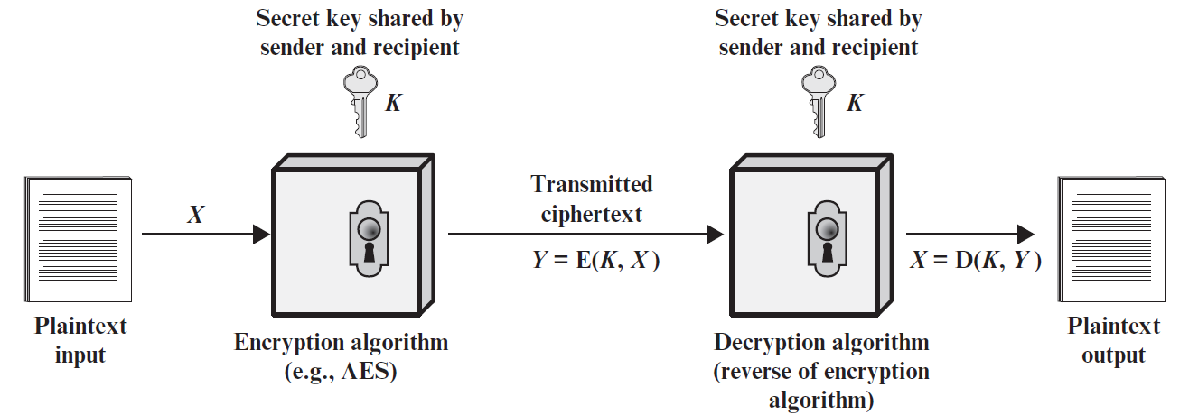

A symmetric encryption scheme has five ingredients:

1. **Plaintext**: This is the original intelligible message or data that is fed into the algorithm as input.
2. **Encryption algorithm (Cipher):** The encryption algorithm performs various substitutions and transformations on the plaintext.
3. **Secret key:** The secret key is also input to the encryption algorithm. The key is a value independent of the plaintext and of the algorithm. The algorithm will produce a different output depending on the specific key being used at the time. The exact substitutions and transformations performed by the algorithm depend on the key.
4. **Ciphertext:** This is the scrambled message produced as output. It depends on the plaintext and the secret key. For a given message, two different keys will produce two different ciphertexts. The ciphertext is an apparently random stream of data and, as it stands, is unintelligible.
5. **Decryption algorithm:** This is essentially the encryption algorithm run in reverse. It takes the ciphertext and the secret key and produces the original plaintext.

## Related Terminologies

**Encrypt (Encipher):** The action of converting plaintext to ciphertext.

**Decrypt (Decipher):** The action of recovering plaintext from ciphertext.

## Requirements and Assumptions

The following two requirements must be fulfilled for a symmetric encryption scheme to work:

1. A strong encryption algorithm that is complex enough, and
2. A secret key known only to sender and receiver (also, sometimes known to trusted third parties).

It is assumed that the encryption and decryption algorithm is known to the public (including adversaries and attackers).

## Mathematical Representation

The operation of encryption and decryption can be denoted as the following:

**Encryption**

Y = E (X, K)

**Decryption**

X = D (Y, K)

|  |  |
| --- | --- |
| **Notation** | **Meaning** |
| X | Plaintext |
| Y | Ciphertext |
| K | Symmetric Encryption Key (Secret Key) |
| E | Encryption Algorithm |
| D | Decryption Algorithm |

## Video Demonstration of Symmetric Encryption

* <https://www.youtube.com/watch?v=AQDCe585Lnc>
* <https://www.youtube.com/watch?v=FmWH1gMvOD8>
* <https://www.youtube.com/watch?v=hP7-kuHBLD4>

## Classical Substitution Ciphers

A classical substitution cipher is a type of encryption technique where each letter in the plaintext is replaced with a different letter from the alphabet, or by some numbers or symbols. If the plaintext is viewed as a sequence of bits, then substitution involves replacing plaintext bit patterns with ciphertext bit patterns. To decrypt the ciphertext, the recipient needs to know the exact substitution mapping and reverse the process by replacing each ciphered letter with its corresponding plaintext letter.

Examples: Caesar Cipher, Vigenère Cipher, Simple Substitution Cipher, Atbash Cipher, Polybius Square, Playfair Cipher are a few examples of classical substitution ciphers.

# Caesar Cipher

The Caesar cipher is one of the simplest and oldest encryption techniques. It was named after Roman Emperor Julius Caesar who used this cipher technique.

It involves shifting each letter of the plaintext a certain number of positions down the alphabet. For example, with a shift of 3, "A" would become "D," "B" would become "E," and so on. This substitution process is applied to the entire message, resulting in the ciphertext. To decrypt the message, the recipient performs the reverse shift, shifting each letter back up the alphabet.

The Caesar cipher is a type of substitution cipher and can be easily cracked through frequency analysis. Despite its simplicity, the Caesar cipher laid the foundation for modern encryption techniques.

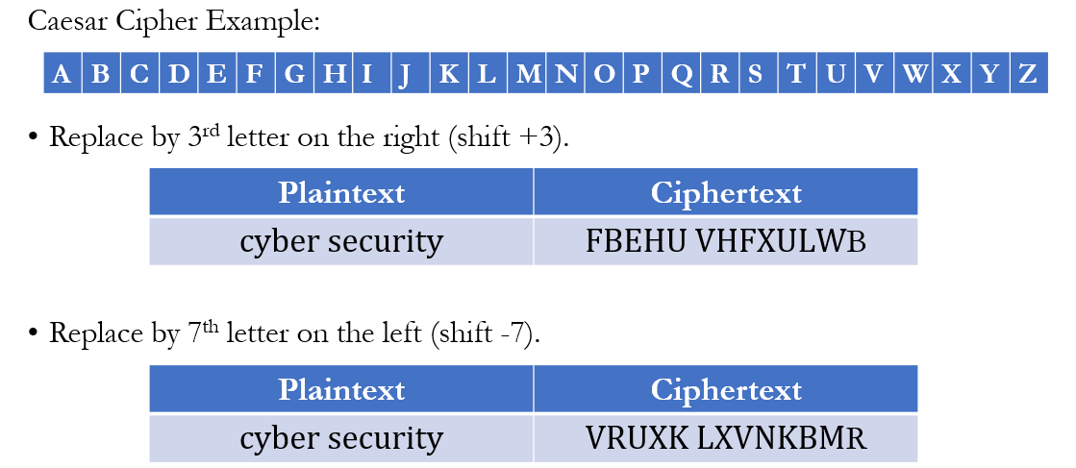

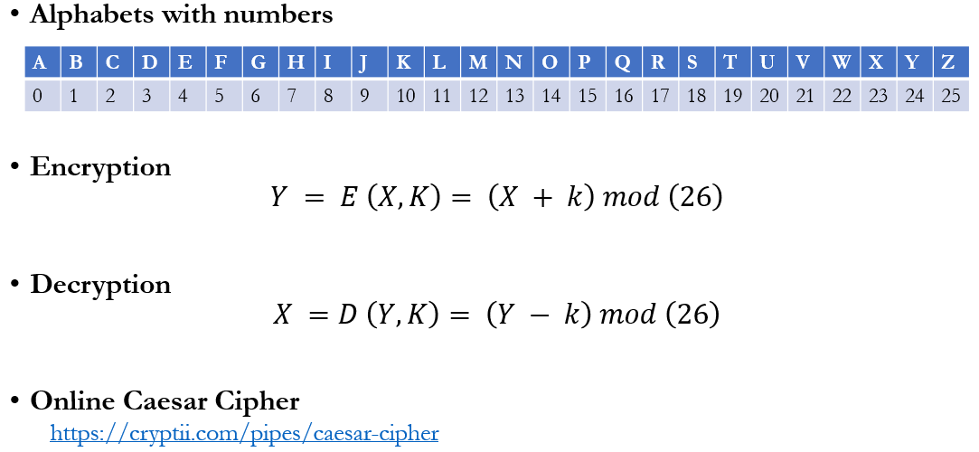

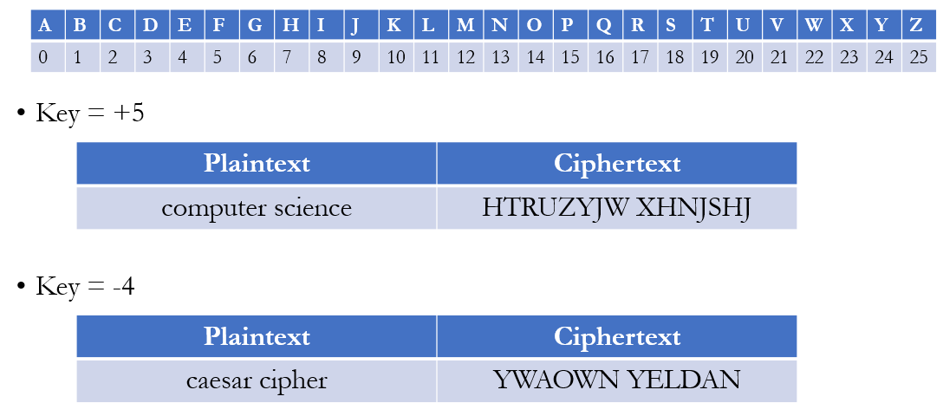

## Cryptanalysis of Caesar Cipher

For English alphabet set, there are only 26 possible ciphers. Within any ciphertext, letter ‘A’ maps to either of the letters: ‘A’, ‘B’, ‘C’, …, ‘Z’. Cryptanalysis would simply try each letter in turn to try to find plaintext. Therefore, a Brute Force Search will break Caesar Cipher within a short time. Codebreaking must know that the ciphertext was coded using Caesar cipher.

# References

[1] Book: Cryptography and Network Security, William Stallings, 7th Edition. Chapter 3, Section 3.1.

[2] <https://www.geeksforgeeks.org/cryptography-introduction/>

[3] <https://www.simplilearn.com/tutorials/cryptography-tutorial/what-is-cryptography>